Coffee waste to Mushroom Farm∗
  - An EPS@ISEP 2019 Project

Erendiro Pedro
ISEP/PPorto
erendiropedro@gmail.com
Ronald Kivipelto
ISEP/PPorto
ronald.kivipelto@gmail.com
Julien Battaglini
ISEP/PPorto
julienbattaglini@gmail.com
Julia Ślasko
ISEP/PPorto
juliaslasko@gmail.com
Alexander Winter
ISEP/PPorto
alexwinter092@gmail.com
Maike Faelker
ISEP/PPorto
mfaelker@gmx.de

ABSTRACT
This paper describes the possibility of developing a business based around the principle of repurposing coffee waste to cultivate oyster mushrooms. The project will be carried out by a multinational and multidisciplinary team enrolled in the European project Semester (EPS) at the instituto Superior de Engenharia do Porto (ISEP). The team benefited from the multinational and multidisciplinary backgrounds, bringing in a range of skills that can be directly applied as well as newly acquired of the team members such as marketing, sustainability and design ethics to consolidate and strengthen the overall feasibility of the project. The project is set to design, develop and test Oyster Mushroom grow kits (using coffee waste as growing substrate) accompanied by an automated monitoring system using the allocated budget and complying with all regulations and requirements set by ISEP. The aim of the project is to connect people back to the food they eat and help spread awareness about sustainable foods which are not only healthy but much better for the environment. The team aims to do this by developing a business model which adopts a circular approach to waste. Oyster mushroom grow kits will be made with waste coffee as well as reusing food buckets as containers to cultivate the mushrooms. Accompanied with these grow kits a fruiting chamber will be developed with a monitoring system integrated into the design. This allows easy and minimum effort cultivation at home and will be able to monitor using a smart phone app. The app will include information regarding the cultivation process, monitoring system, mushroom forum for discussion and other pages such as a recipe page. Tests have been conducted to test the concept and the cultivation process as well as testing the monitoring system and fruiting chamber. Test begin from incubation of mycelium all the way to the harvesting of the Oyster Mushrooms. Results show the feasibility of creating a business based around the discussed concept.
∗Article Title Footnote needs to be captured as Title Note
†Author Footnote to be captured as Author Note
Permission to make digital or hard copies of part or all of this work for personal or classroom use is granted without fee provided that copies are not made or distributed for profit or commercial advantage and that copies bear this notice and the full citation on the first page. Copyrights for third-party components of this work must be honored. For all other uses, contact the owner/author(s).
WOODSTOCK’18, June, 2018, El Paso, Texas USA
© 2018 Copyright held by the owner/author(s). 978-1-4503-0000-0/18/06...$15.00
https://doi.org/10.1145/1234567890
CCS CONCEPTS
• Insert CCS text here • Insert CCS text here • Insert CCS text here
KEYWORDS
Insert keyword text, Insert keyword text, Insert keyword text, Insert keyword text
ACM Reference format:
Erendiro Pedro, Julien Battaglini, Alexander Winter, Ronald Kivipelto, Julia Ślasko and Maike Faelker. 2019. Coffee waste to Mushroom Farm: An EPS@ISEP 2019 Project. In Proceedings of ACM Woodstock conference (WOODSTOCK’18). ACM, New York, NY, USA, 2 pages. https://doi.org/10.145/1234567890
1 Introduction
The European Project Semester (EPS) is a one semester capstone project or internship program offered to engineering, product design and business under-graduates by 19 European engineering schools. EPS aims to challenge students from multiple educational backgrounds and nationalities to join their competencies to solve multidisciplinary real life problems, in that context, in the spring of 2019 at Instituto Superior de Engenharia do Porto (ISEP), a team composed by: Alex Winter, a Product designer student from Switzerland, Erendiro Pedro, an Angolan electrical and computer engineering student, Julia Slasko, a business and technology student from Poland, Ronald Kivipelto, an electrical engineering student from Estonia, Julien Battaglini, a general engineering student from France, and Maike Falker, a media technology student from Germany, came together and decided to develop “Waste to Fungi”, a sustainable mushroom farm using coffee waste to grow.
Coffee is a massive industry, worth over 50 billion dollars in 2019 [1], but when coffee is made only less than 1 percent of the biomass ends up in the cup, in other words, 99 percent of the biomass from the coffee is wasted [2]. This huge amount of coffee waste is still full of nutrients which are a very good growing medium for Oyster mushrooms. With that said, the overall objective of this project is to develop a proof of concept for a sustainable business by which coffee waste is collected and used as a growing medium for oyster mushrooms, as well as developing a chamber to optimize the whole process.
This paper aims to give a better understanding on the entire process the team went through in order to begin creating the business mentioned above. The paper will be divided into 8 sections: the first three sections focusing on understanding the growing process of the mushroom and the different solutions, with that understanding, the 4th section establishes a marketing plan for the business, the 5th and 6th analyses the ethical and sustainability considerations of the project, and with all that, in the 7th section a description of the design and development of the business will be provided, the 8th we present the results the team had at the present time and finally, in the last section is reflected on the main conclusions of the project.
1 Problem and solution
1.1 Coffee lifecycle
Starting from the simple observation that Portuguese are heavy coffee consumers. Information which is backed by Statista who states that 40 tons of coffee is consumed each year in Portugal [3].
The team wondered how the coffee ground was used after being brewed, the sad reality is that most of the coffee beans travel thousands of miles to extract their precious flavor but the remaining coffee ground and nutrients contained in it are considered as waste and thrown away by coffee shops.
1.2 Grey Oyster Mushroom cultivation
An existing process to repurpose coffee grounds is to cultivate and grow Pleurotus Ostreatus also known as grey oyster mushrooms. Indeed, this specific variety is well known for its taste, but it also has the specific feature to grow extremely well on coffee grounds due to coffee being high in cellulose [4]. This interesting feature would enable to get coffee into a more sustainable age by offering it afterlife when growing mushroom out of it.
1.3 Our solution
Combining the two-previous observation we decided to create a mushroom farming system with the main goals of being waste free with the creation of a circular process using the waste of others and repurposing our tooling allowing a more sustainable process. Our solution consists in growing grey oyster mushrooms in coffee waste inside of repurposed or reused plastic containers.
By growing your own mushrooms, you can provide people access to fresh, healthy and organic food which in terms adds to their quality of life. We want to provide a service by which we provide people with grow kits that allow cultivation on various scales to be done at home.
2 Design structure
The team decided to create Waste to Fungi, more than just a product, it’s a business designed to fit within a circular economy. It’s designed around two mottos, the first one being reuse, in which we consider that everything used in the process should be used for a lifetime. Standard mushroom producers use plastic bags for the cultivation process, we decided to reuse plastic buckets as a container for our mycelium to be inoculated. Providing the service of recolonizing the used buckets with mycelium. Fully colonized buckets are then bought by customers.
The second one aiming to fill the existing gap between waste and trash, by repurposing and giving value to the waste of others creating a more circular economy.
The product we offer is a mushroom bucket filled with fully colonized mycelium that will allow the growth of fresh oyster mushrooms.
Made out of repurposed buckets it can be reused or recycled if it is too damaged. Alongside we developed a chamber which will enable the user to achieve optimal parameters for growing mushrooms by controlling and adjusting temperature and humidity. Surrounding the business there is an educational aspect by which the service hopes to provide information and courses that teach people and families about the process and benefits of growing mushrooms. This is not only an enriching and rewarding process but expands people awareness and knowledge in sustainable food systems. This may encourage more environmentally friendly practices.
3 Cultivation process
3.1 Growing mushrooms in coffee
Mushrooms are notoriously hard to grow because of inconsistent results. This is partly due to the mass production of low-quality grow kits which give unreliable results. Even in the wild mushroom’s growth is very unpredictable. However, by using the correct knowledge and relatively simple techniques it is possible to cultivate mushrooms on both an industrial and home scale.
Similar to the fruits produced by a tree, mushrooms are the reproductive fruits of a dense rootlike network of cells known as mycelium. When mycelium runs out or it’s put under some type of environmental stress it switches into survival mode and produces mushrooms in order to release its spores into the wind to find a better place to live [5]. Lucky for us it is possible to recreate and manage the life cycle in order to cultivate good crops of edible mushrooms. Mushroom farming heavily relies on very strict growing conditions and minimizing competition through pasteurization. However, this can cost quite a lot for someone who wants to grow at home. One of the aims is to make it as cheap and rewarding as possible.
For this reason, Oyster mushrooms are a great place to start as they are very resilient and can grow in many types of agricultural waste [6]. The most common materials used to grow Oyster are freshly cut hardwood logs or straw. Growing on logs can be quite difficult and can take several years before your first harvest. Growing on straw requires pasteurization to kill off any micro-organisms that will compete with mycelium.
Growing in coffee has quite a big advantage as it has already been pasteurized by the brewing process meaning it is ready for inoculation, skipping out the pasteurization step.
It is crucial that the team has a solid understanding of mycelium because this is what mushrooms fruit from. Without healthy cultivation of mycelium, fruiting of the mushrooms will not occur. A mushroom farm firstly needs to cultivate mycelium and then through the maintenance of the right conditions (high moisture, high oxygen and the right temperature) will cause mushrooms to grow. Paying close attention to the health and growth of mycelium will help to achieve bigger yields.
3.2 Our cultivation process
3.2.1 Acquiring substrate and spawn.
Because the business is based around growing mushrooms in coffee waste, the mushroom best suited to do this is the Oyster mushroom. Coffee has loads of cellulose in it which is essential for the cultivation of Grey Oyster Mushrooms. Pleurotus ostreatus Grain spawn was bought from a supplier called Horta do Marão close to the production point in Porto.
3.2.2 Bucket Preparation.
Recycled food buckets where collected from cafeterias and restaurants around the production point. 10mm hole were drilled into the sides of the buckets in a uniform pattern. These holes are where the mushrooms will grow out of. On the day of production fresh coffee waste was collected in plastic zip-lock bags. Coffee waste was mixed with hay with a ratio of 1:5. For guaranteed results the team decided to fully sterilize the substrate with an autoclave. Substrate mix was placed into 2L glass beakers. They are then placed into the autoclave and heated to 121 °C for a total of 20 min. Once the substrate had cooled back to room temperature 3 kg of substrate mix was mixed with 100 g of grain spawn. Before buckets are filled with the mix they are cleaned with 70 % Ethanol and holes are sealed with breathable tape. In order to have comparative results the team decided to use a control group where the coffee in the substrate mix was not sterilized in the autoclave. This not only provides a control group but also checks whether full sterilization is necessary.
3.2.3 Incubation.
Once buckets are prepared they are placed into a dark environment at a temperature of around 20 °C. They will remain here until the substrate has been fully colonized by the mycelium. This will be monitored by the team with daily visual checks for growth and contamination.
3.2.4 Fruiting.
Once the substrate mix has been fully colonized by the mycelium, the buckets can be moved into fruiting chamber where they will be introduced into a high humidity environment (60-80 %) around temperature of 24 °C (within a range from 20 °C to 28 °C). Humidity and temperature will be monitored with the monitoring system the team developed and will be adjusted accordingly. With a week or two the first set of mushrooms should have matured.
3.2.5 Harvesting.
Once mushrooms have fully matured the mushrooms can be handpicked will a twisting motion. All mushrooms must be removed. The process will then restart. Typically, 3 to 4 harvests are expected.
Once the buckets stop fruiting mushrooms the bucket will be removed from the fruiting chamber. Substrate can be emptied and mixed into new substrate so mycelium within the substrate can be recycled. Buckets are cleaned and stored for the next grow.
4 Marketing
4.1 Market analysis
In order to develop marketing plan, the team had to start with the market analysis. The coffee, mushroom consumption and sustainable foods markets were taken into consideration to define the need for the product being developed. Moreover, the strengths, weaknesses, opportunities and threats of the business were identified using the SWOT framework. Thanks to this useful tool, the awareness of the internal and external factors that can have an impact on the viability of a project, product, place or person was raised. On top of this the team conducted a survey to gain a much richer understanding of the target audience and their needs as consumers. This made it a lot easier to justify marketing strategies as they were supported with results from the survey. The full results of the survey can be found within the teams detailed report.
4.2 Existing solutions
The team had to go through existing solutions and competition to find a niche, the two main competitors that were found being the following:
- Mushroom kits, which allows the consumer to grow fresh mushrooms at home. The kits are composed of a plastic bag filled with fully colonized mycelium allowing the consumer to harvest its very own mushrooms. It usually is made using grey oyster mushrooms and coffee ground and pricing is ranging from 9 to 20 euros
- Mushroom farms, which allows the consumer to buy either fresh, packed or canned mushrooms. Mushroom farms usually operate on a large scale both in quantity and variety and distributing more on a global market rather than a local market.
The team decided to differentiate itself from other grow kits by not only reusing coffee waste and other materials but by creating a service surrounding the grow kit, providing refilling of buckets with fully colonized mycelium, and allowing customers access to learning resources such as workshops and monitoring systems and community forum.

After the research and analysis about the market the customer segmentation was performed in terms of geographic, demographic, behavioral and psychographic aspects. Then, it was possible to create adapted marketing mix, which consist of 4P place, product, promotion and placement. The product will be dedicated to mushroom lovers, which are concern about the environment and healthy organic food. The main headquarters of farm and selling store would be on ISEP university, where cultivation of mushrooms, educational workshops and selling buckets with chamber will take place. The team decided to differentiate the offer and create three options based on interest, where customer can decide to buy only bucket, bucket with chamber or bucket, chamber and sensors. The plan is also to create loyal customer base where it would be possible to get discounts and return equipment with reduction. Promotion was considered as a one of the most important aspects at the beginning of the business, so it would be conducted on the several platforms such as website, social media, cooperation with local cafeterias (in order to spread information, create discounts for customers) and local communities in sense of educational purpose (schools, environmental organizations and restaurants).
5 Sustainable development
Sustainability is about ensuring the well-being of the socio-ecological system. A goal of preserving life on Earth has become a challenge. Industry has to change and businesses need to apply more radical sustainable measures. One area where difference can be made is product development. During the design phase, environmental impacts have to be taken into consideration and the whole life cycle of a product should be analyzed and made more efficient to adopt a more circular approach. Businesses usually focus their efforts in environmental control on the end of the product life cycle which actually don’t produce environmental solutions, but rather prolong the problem. More environmentally conscious businesses are implementing other sustainable concepts and practices that have a more significant impact on the environment, emphasizing the principles of maximum value with minimum resources. These concepts and practices include optimizing eco-efficiency, extending product responsibility and function, design for the environment, design product services and by-product synergy (one industry's waste stream is another industry’s primary resource). Many of these concepts are derived from a more circular economy business model. This model aims to transform traditional linear models of production whereby raw materials enter and products and its waste exit the system into a more integrated (circular) industrial ecosystem. This model uses optimization of energy and material consumption and waste minimization, where the non-valuable outputs of one process (commonly denominated ‘residual waste’) serve as valuable input for other processes. Businesses must analyze their product life cycle and decide what areas are best suited to implement potential solutions and optimize as much as possible. Modularity is essential in product design, as it simplifies the repairing process. When parts are easy to disassemble, and are made of recyclable materials, they would enter a new cycle as raw materials, rather than be disposed.
The mushroom farm project incorporates circular economy practices to be as sustainable as possible. The company provides a subscription based service, in which customers get to use grow kits. These are made out of reused plastic buckets from food industry. Inside the buckets contains coffee waste on which the mushrooms grow. After harvest is done, the container is returned to the company and is made into a grow kit again. Waste resource collection and product distribution will all be conducted locally to minimize the negative impacts. This means less pollution created by transportation. Using coffee leftovers and reused buckets keeps waste creation at minimum. Preparing grow kits is done by human hand, therefore energy consumption is low. Thriving towards sustainability a company needs to minimize negative impacts on the environment by constantly adapting to best practices.
6 Ethical and Deontological concerns
When designing a product, it is crucial to do that regarding different aspects of ethics and deontology as it is fundamental for our company’s reputation and therefore for our products success.
Concerning Engineering ethics, we want to make sure to develop and create our product in accordance with safety, health and welfare of the public. Also, it should not be, or as less harmful as possible to the environment. We are creating Waste to Fungi for the benefits of whole and therefore contributing to a better society, by creating solutions to connect, or help people in a more general way.
When thinking about advertising a product, doing it ethically is less of a marketing strategy and more of a philosophy which should seek to promote fairness, honesty, and responsibility. Since unethical advertising is not necessary against the law and unfortunately just as effective as ethical marketing, many companies use it for their advantage. But for Waste to Fungi to have a reliable and trustworthy reputation, treating customers fair and advertise the service and product in the most transparent and honest way possible is of high importance.
Another aspect that needs to be considered, especially with regard to current events is the environmental ethics. The main core of environmental ethics is finding the balance between social, economic and environmental aspects and try to be more sustainable in all actions. We want to keep Waste to Fungi’s environmental impact as low as possible therefore we are reusing components of our product and striving for a circular economy approach.
The Liability of our product should also be of importance as it is the legal aspect of the product, preventing the company to be sued for damages or incidents created by their product or its use therefore Waste to Fungi decided to comply with some of the EU directives. Since Waste to Fungi delivers a service allowing to grow food, that would be eaten after growth, it is necessary to make sure to comply with existing food directives in Portugal in order to avoid any case of food poisoning.
7 Project development
7.1 Requirement and functionalities
The team decided to define requirements in order to measure the success of the process. Functionalities were developed based on project requirements and tests were used to check whether or not these requirements have been met. Table 1 features the functionalities, requirement and tests we decided to adopt in our product.

The project has the following requirements:
- Automatic monitoring and control of the chamber conditions
- The medium or small scale of the device
- Usage of low-cost hardware solutions (Not exceed the budget of 100 € for the construction of prototype)
- Usage of the open source software
- Adaptation of the International System of Units (NIST International Guide for the use of the International System of Units)
- Comply with EU Directives [7] [8] [9] [10] [11]
7.2 Bucket
This section is intended to provide a short description of our buckets showcased in Figure 1
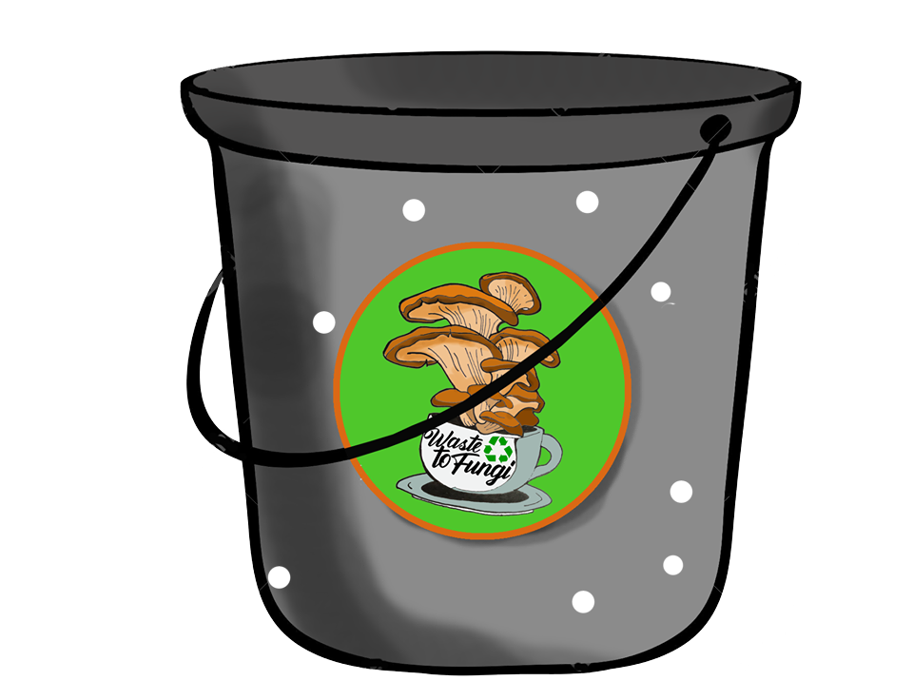
Figure 1 - Bucket

The buckets, or other containers we use, are made of plastic packaging that has already been used at least once in the food industry. They have holes to enable fresh air supply for the mycelium development and for the mushroom to fruit.
7.3 Chamber
This section is intended to provide a description of the chamber and its functionalities. The chamber is presented in Figure 2:
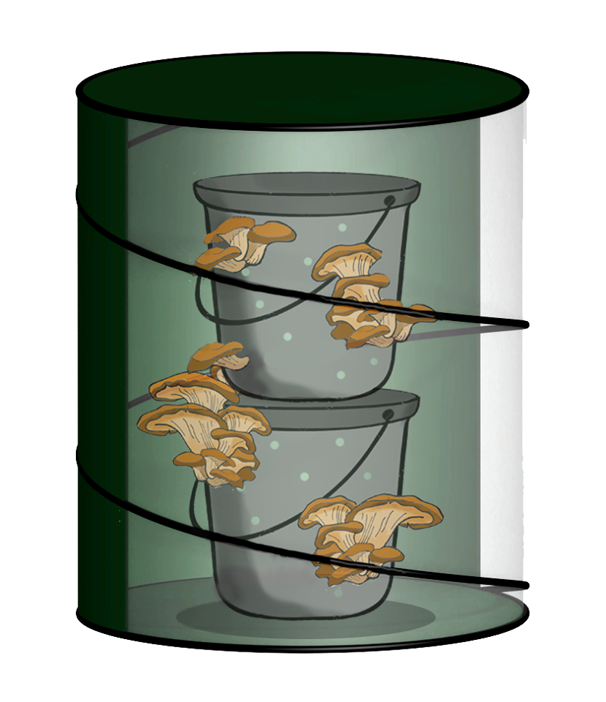
Figure 2 - Automated chamber
The chamber allows to simulate a suitable environment for two phases of the mushroom process, by regulating humidity and temperature, creating an airflow and allowing indirect light to help mushroom grow. This is made using fans, resistors and an automatic sprinkling system.
7.4 Circular economy
This section is intended to provide a description of how our products are incorporated in a circular economy as presented in Figure 3
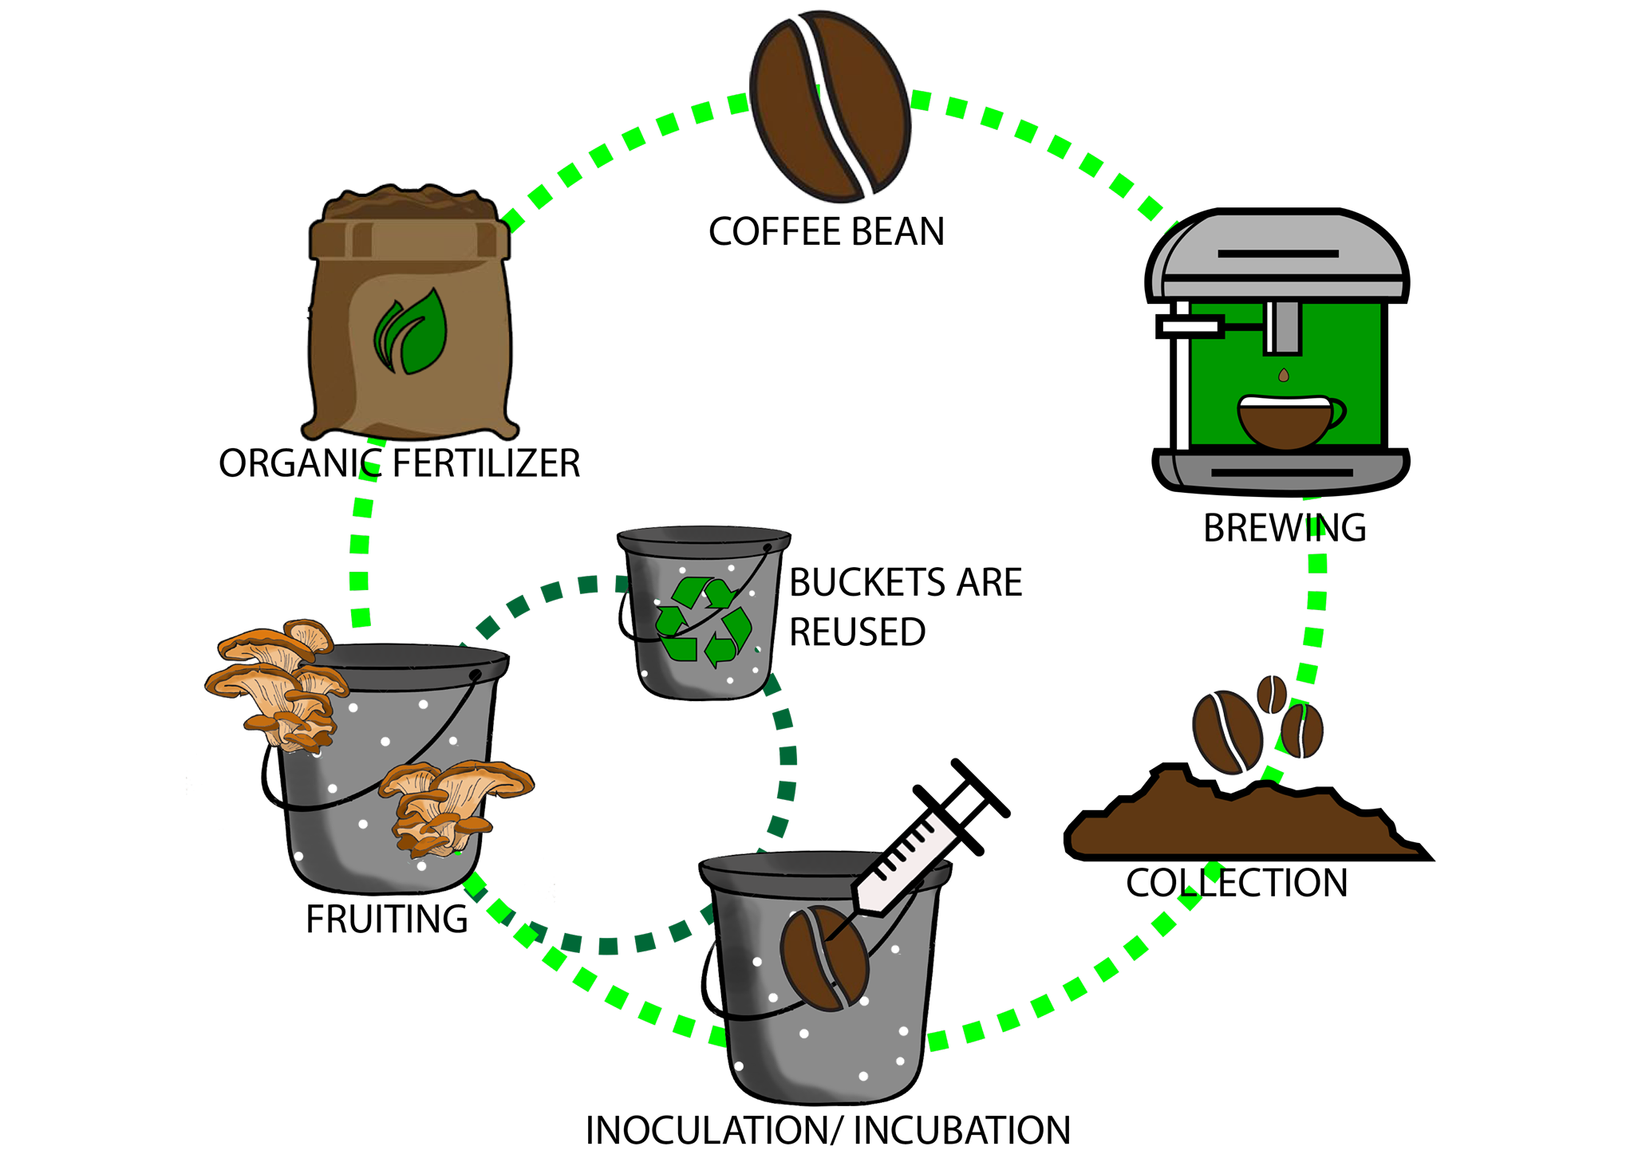
Figure 3 - The circular economy surrounding our mushrooms
In Figure 3, different actors are part:
- Restaurants: They provide coffee waste produced by brewing coffee
- Logistics: Insured by us, transportation would be made using an electric cargo bike, allowing collection of coffee waste, buckets and others in the most sustainable and effective way.
- Coffee inoculation: Insured by us, it consists of the mixing of mycelium and coffee, as well as tracking of contamination for the safety of our customer.
- Growing and Harvesting: Customers would grow mushrooms at home using our buckets and chamber before returning fully fruited buckets for us to reuse.
- Organic waste would be used as fertilizer to cultivate coffee again or other types of cultures.
- Other services that would be provided by waste to Fungi are:
- Education by teaching people about mushroom cultivation, and the universe around.
- Awareness by spreading knowledge about solutions to live in a more sustainable world.
7.5 Controlling system and app
This section is intended to provide a conceptual description of the structure and behavior of the electronic system of the chamber.
For the chamber is idealized a system that can accurately read the temperature and humidity, and through those values, automatically maintain the chamber in the right condition for mushroom cultivation. The described system can be represented in terms of its inputs and outputs (Black Box Diagram), as shown in Figure 4:
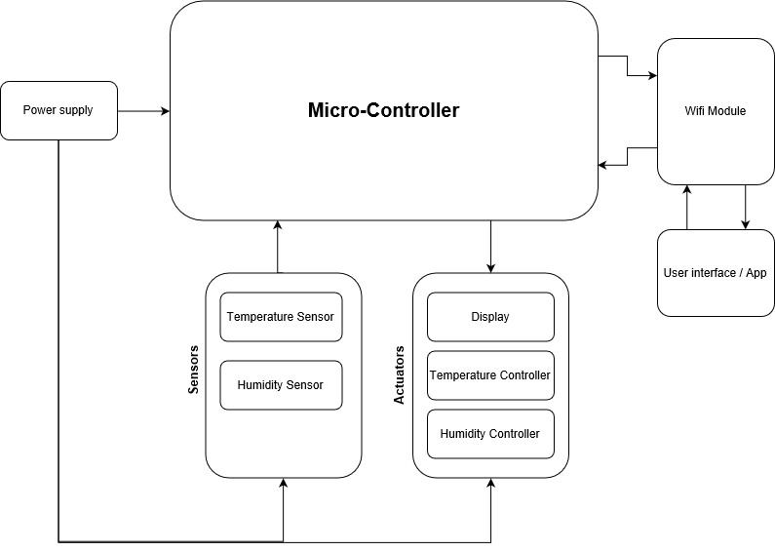
Figure 4 - Black box diagram
To achieve the control system described above, the team decided to use two temperature and humidity sensors and according to the values recorded by them activate actuators to constantly adjust does two parameters. Two fans are being used for cooling, increasing the speed of them accordingly to the temperature of the chamber. Power resistors are being used to warm it up in case of temperatures below ideal, and finally a servo motor to trigger a sprinkler that increases the humidity when it’s needed. With this system, it’s possible to better optimize the control of the temperature and humidity of the system, thus facilitating the cultivation of the mushrooms.
In addition to that, with the help of a Wi-Fi module, the data of the sensors are sent and stored in a server in the cloud, making it possible in the future to carry out studies on the ideal conditions for cultivating mushrooms.

A detailed schematic of the system is featured in Figure 5:
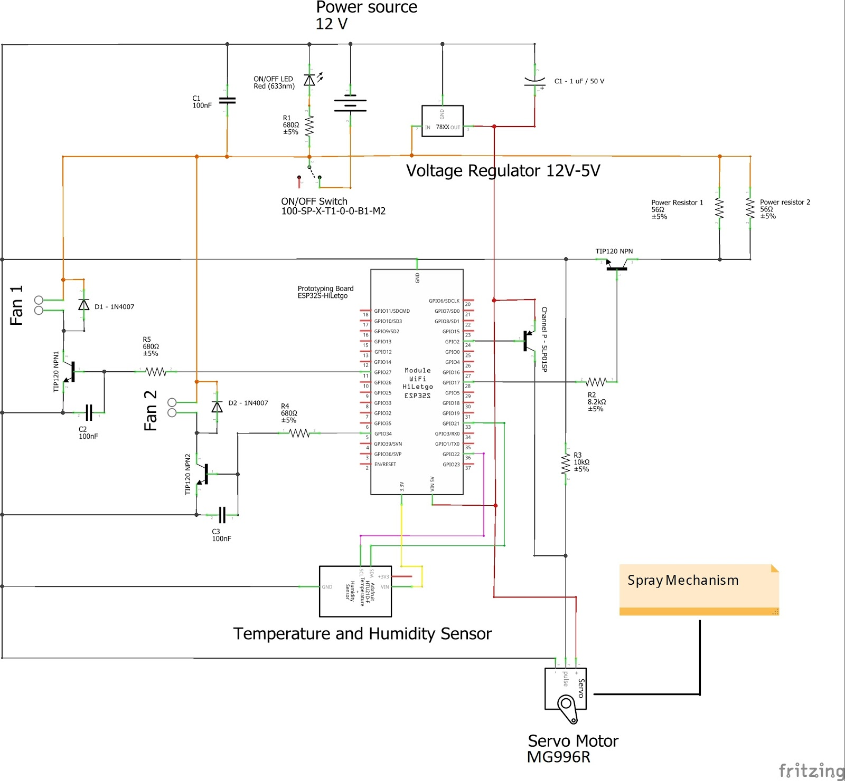
Figure 5 - Electronics schematic

8 Tests and results
In order to ensure the proper functioning of the final prototype, several tests must be performed. The methodology behind the testing will be based on trial-and-error, which means that the code will be tested, in case of error debugged and tuned, until the desired results are achieved, which in this case is for the chamber prototype to be able to maintain all the proper theoretical conditions for mushroom cultivation.
8.1 Electronics tests and results
Monitoring system needs hardware and software testing, which are done at the same time. Different components of electrical circuit can be checked separately. While connecting part of a circuit to the power, it is identified if the component is faulty or not. Software test includes temperature and humidity sensor, as well as mobile app for monitoring its output values. Code is run in order to see if the readings are correct. At this stage, it can be seen if there are communication errors between app and the sensor.
The chamber prototype was tested in tthree instances:

For the first test the prototype was placed into the setup shown in Figure 6. In that setup the entire system is within a low light room with a relatively low temperatures (18 ºC - 23 ºC), a bucket with water is being used to keep the humidity in the ideal range (40% - 60%).
The tests started at 2019-06-08 16:17:20 in Braga, Portugal and finished at 2019-06-09 10:34:22 in Braga, Portugal. The team managed to actuate on the system track of the proposed parameters for about 17h, as can be seen in Figure 6.

Figure 6 - Setup 1
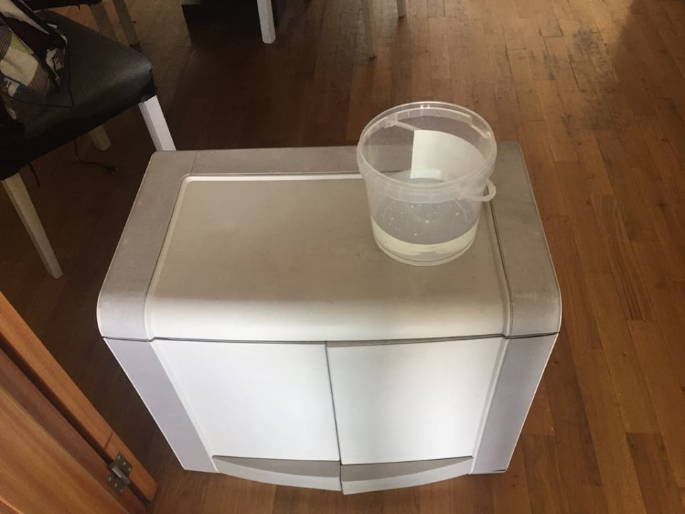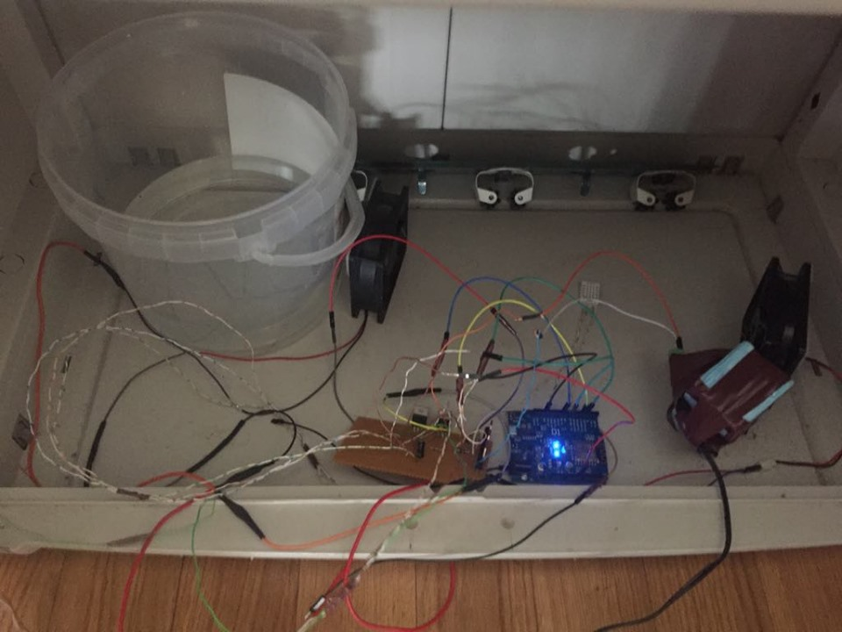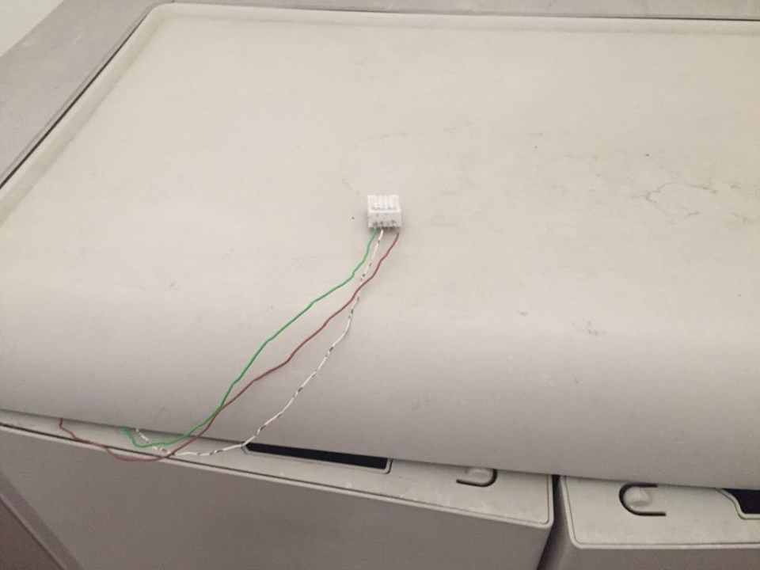

The objective is to see if the system can properly monitor the temperature and humidity of the place.
The tests started at 2019-06-08 16:17:20 in Braga, Portugal and finished at 2019-06-09 10:34:22 in Braga, Portugal. The team managed to keep track of the proposed parameters for about 17h, as can be seen in Figure 7.
Figure 7 - Monitoring results for setup 1
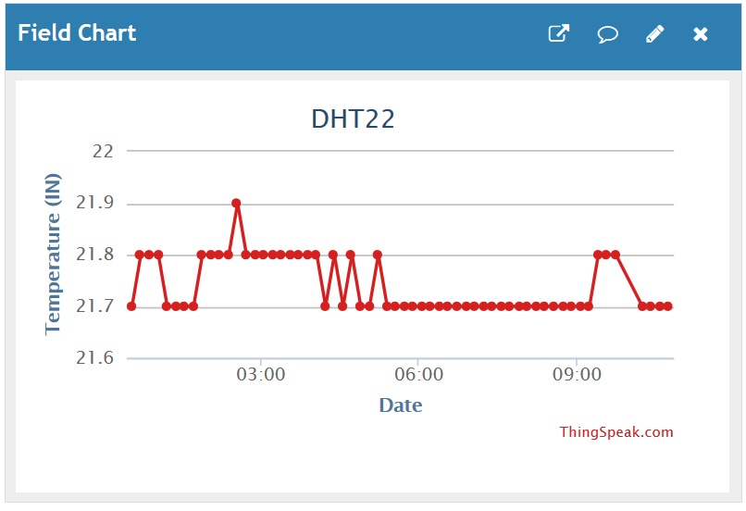
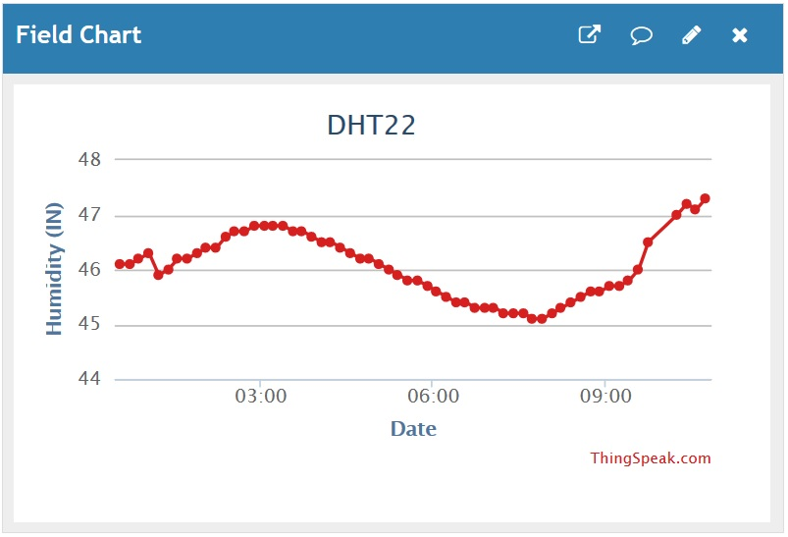

With the data acquired is possible to infer that the “place” monitored could be adequate for mushroom cultivation.

In a second instance the prototype was placed in a small box with the fans on, in order to see the effectiveness of the cooling system, as shown in Figure 8.

Figure 8 - Setup 2
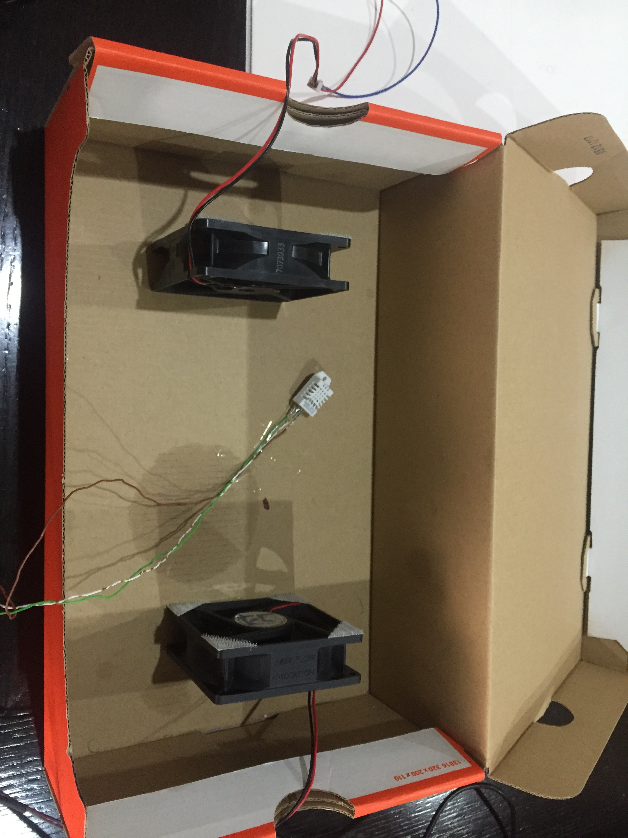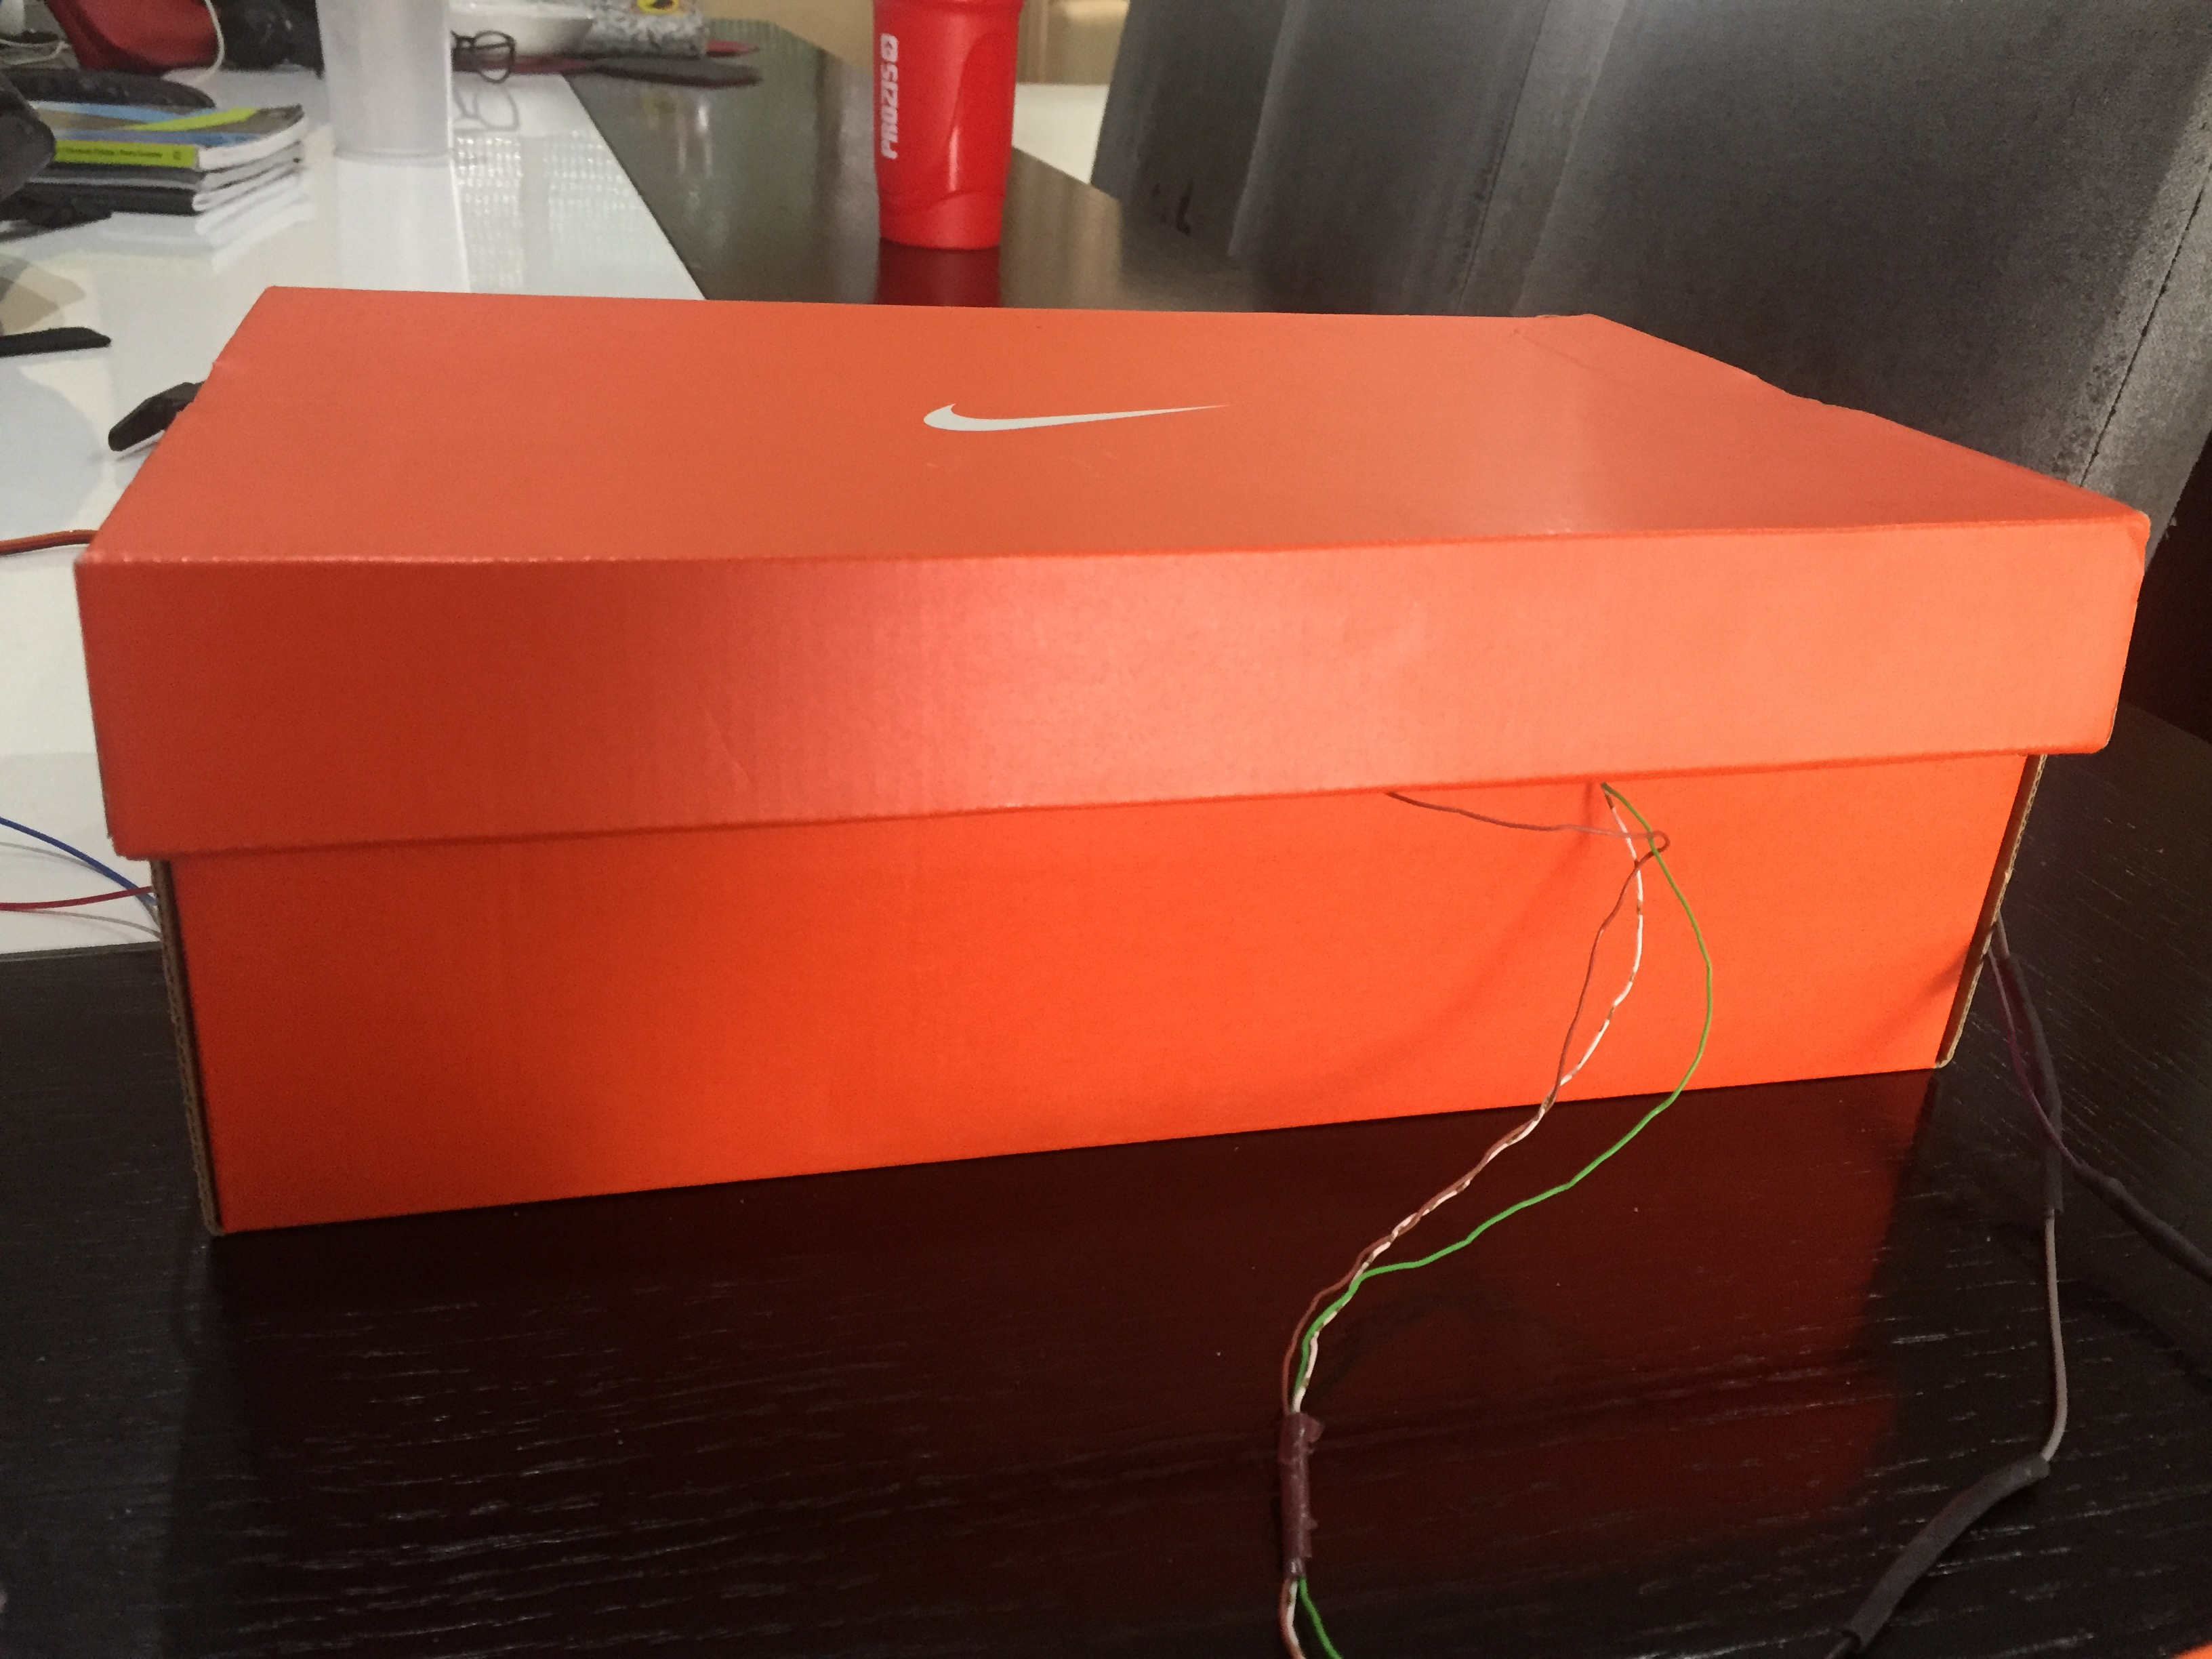

The tests started at 2019-06-15 16:00:23 in Braga, Portugal and finished at 2019-06-15 17:45:41 in Braga, Portugal. The team managed to actuate on the system for about 2 h before concluding.

Figure 9 - Monitoring results for setup 2
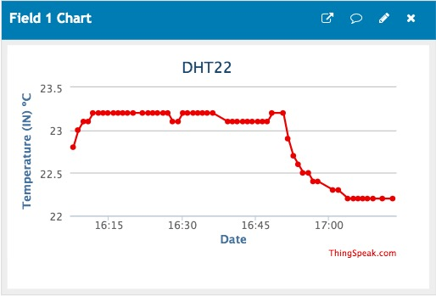

With the obtained results the team concluded that the designed system isn’t effective on reducing the temperature of the chamber, only managing to reduce it from 23.2 ºC to 22.2 ºC (still not within the desired range), as can be seen in Figure 9.

In a third instance the prototype was placed in the chamber with the fans on, and the servo motor working, as shown in Figure 10.

Figure 10 - Setup 3
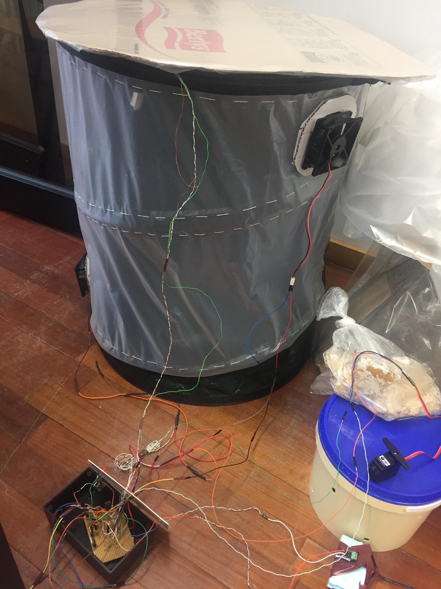

The tests started at 2019-06-16 18:45:17 in Porto, Portugal and finished at 2019-06-16 19:10:21 in Porto, Portugal. The team managed to actuate on the system for about 1 h before concluding.

Figure 11 - Monitored results for setup 3
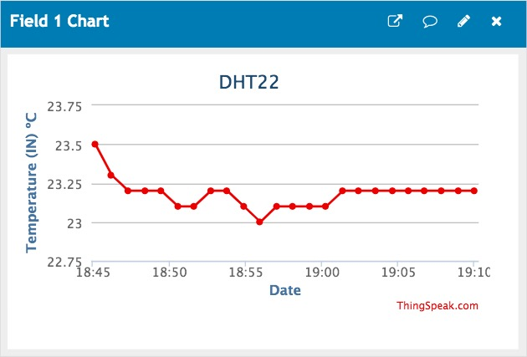

As expected from the test performed before (Figure 9) the system wasn’t effective on keeping the parameters within the desired range, as can be seen in Figure 11.
8.2 Cultivation tests and results
Mushroom cultivation process testing is about monitoring the grow kits and documenting the process by taking pictures. There is a risk of contamination. If it happens, infected grow containers are removed, and the causes are investigated. Mushroom cultivation is a long process; Therefore, it is important to keep right temperature and humidity conditions in the testing room.
Only a sample of the buckets from the first cultivation batch are displayed in this paper as an example. The full results and tracking can be found in the teams detailed report. Link to full results can be found in the reference section of the paper. First Cultivation batch was produced on 7/05/2019. Figure 6 and 7 show the recorded temperature and humidity for a 4 weeks period. Figure 8,9,10 and 11 are a series of images that show the mycelium development starting with the 1st week all the way to the 4th week.

Figure 12- Temperature of Incubation site
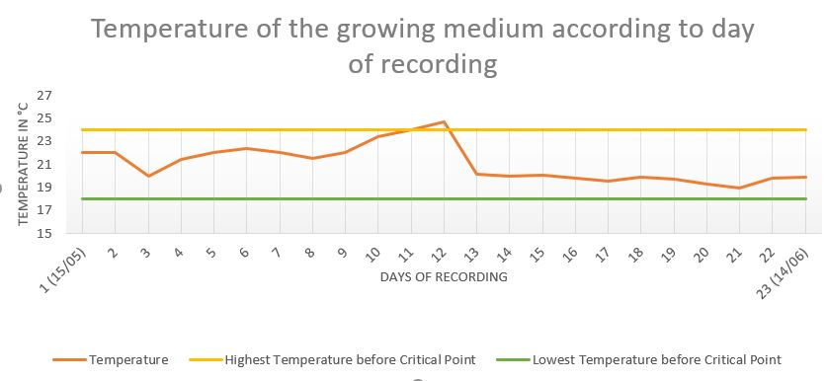

Figure 13- Humidity of Incubation Site
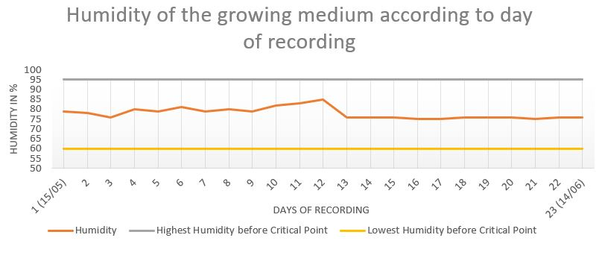
Figure 14- Week 1 of Cultivation
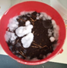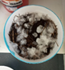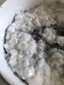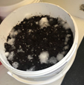
Figure 15- Week 2 of Cultivation
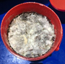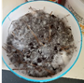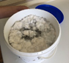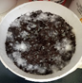
Figure 16- Week 3 of Cultivation
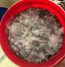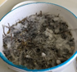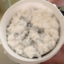
Figure 17- Week 4 of Cultivation
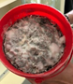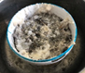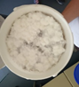
8.3 Explanation of Results
The results of the first batch of buckets are still ongoing. Despite all the buckets having a good start there were some issues with the internal humidity of the bucket being too high. You can see within the second week there was a peak in temperature and humidity which led to some contamination issues. Contaminated buckets were isolated and observed so the contamination could be identified and diagnosed. One of the control buckets where substrate was not pasteurized showed early sign of Green mold. This was most likely caused by the waste coffee used not being fresh and was already contaminated. Some of the buckets were contaminated with neurospora. The pasteurized substrate with increase in humidity and temperature allowed neurospora to quickly colonize on various buckets. The team had much more success with the buckets that used coffee waste that had not been pasteurized. This may be because by pasteurizing the substrate creates a better and more neutral environment for the neurospora to thrive. Increase in temperature came down to weather and poor ventilation in initial incubation site. The team has since now moved the incubation site to a new area where it is much better ventilated, and temperature and humidity remains in appropriate range. Temperature and humidity are carefully being monitored with the monitoring system developed by the team, alongside daily visual inspections. These changes are bringing promising results, with the first bucket beginning to fruit (Figure 12). The team will continue to document the cultivation process in the detailed report which can be found in the references.

Figure 18- First 3 days of Fruiting
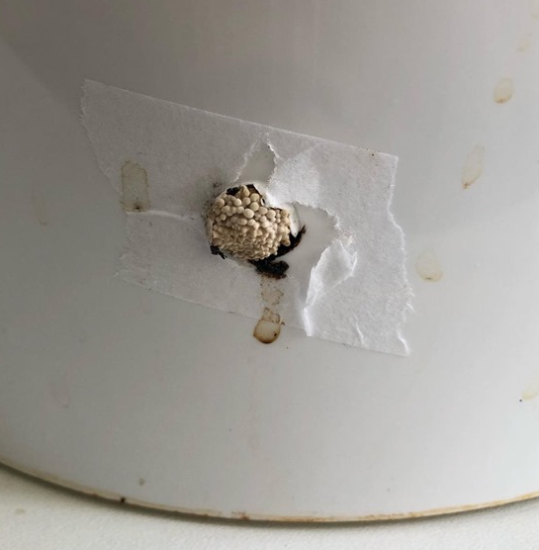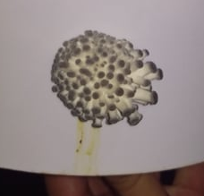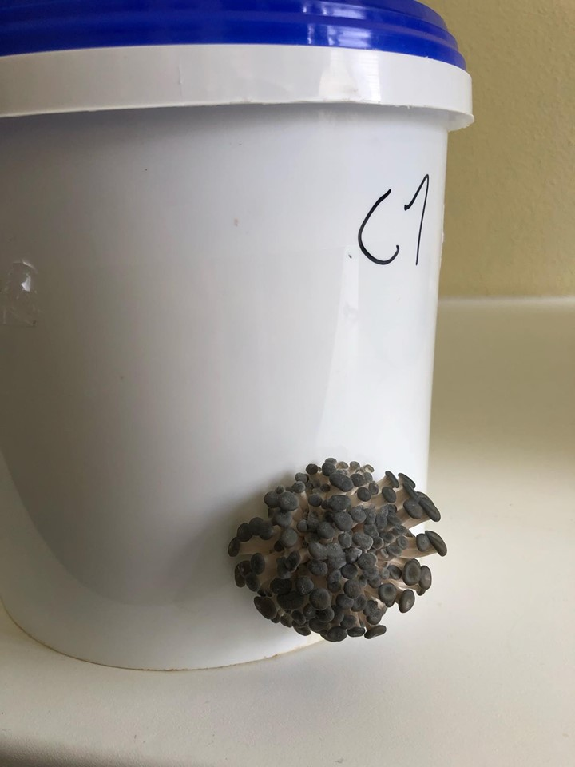
Conclusion and evaluation
The team set out to test the feasibility of creating successful business surrounded the idea of using coffee waste to grow oyster mushrooms and to develop multidisciplinary skills that may prepare them for future employment. The team was able to create a marketing plan to promote the grow kit and the surrounding service to target consumers. A detailed business plan was created to specify logistics, costs and funding, supplies and target consumers. This allowed the team to fully specify the ins and out of the business to potential sponsors for future funding. In terms of the cultivation process, arguably the most important part, the team has made a good start in refining the process and are testing the concept. Despite some initial failures with contaminations the team is closer to understanding the process in much more detail and all the potential risks associated with the cultivation process. The team will continue developing and analyzing a safe, reliable and repeatable process which will allow the cultivation of large yields of Oyster mushrooms. The team would like to investigate potential sources of contamination in order to prevent risks in future cultivation and develop counter measures for prevention. The fruiting chamber was developed and prototyped and the functionality was tested. The team was not able to monitor the actual growing of the mushrooms due to contamination issues and time lags however the team is striving toward a successful cultivation of a fully colonized bucket of mycelium. This can then be used to cultivate mushrooms inside the fruiting chamber which will allow the team to conclude their investigation into the cultivation process. Prospectively, to guarantee success the team would invite an expert to share some knowledge into optimizing the cultivation process while eliminating risk. Another option would be to partly outsource the inoculating process, whereby the team would collect the raw materials to build the growing substrate, while an external company (with more expertise in the field) would inoculate and colonize the buckets. Once the buckets have been fully colonized the team would distribute the buckets to consumers.
Collaborative work can be difficult, especially in a multi-cultural and multi-disciplinary context. One of the biggest challenges the team faced was time management while organizing logistics and distributing tasks amongst the team members. The team worked with each member’s strengths which consolidated their own knowledge in the field while also developing many other skills in subjects such as marketing and sustainability. Soft skills such as organization and communication were also practiced and developed. All the team members can agree that the EPS@ISEP was a very useful experience in not just personal development but also preparing them for future employment. Not to mention the whole experience allowed the members to explore Portugal and indulge into its rich culture.
ACKNOWLEDGMENTS
The team would like to thank ISEP and the EPS supervisors for the opportunity to take part in this great learning experience. They would like to give a special thanks to professor Abel Duarte and the microbiology technicians for their help and support.
They would also like to give a special thanks to INESC TEC for providing an area to test our cultivation process.

REFERENCES
[1] Markets, Markets, Mushroom Market by Type (Button, Shiitake, and Oyster), by Application (Fresh Mushrooms and Processed Mushrooms (Dried, Frozen, and Canned)), & by Region - Global Trends & Forecast to 2019. https://www.marketsandmarkets.com/Market-Reports/mushroom-market-733.html .
[2] Grocycle, Growing Mushrooms In Coffee Grounds, Adam Sayner, 2019 https://grocycle.com/growing-mushrooms-in-coffee-grounds/.
[3] Statista, Coffee ein Portugal, https://www.statista.com/outlook/30010000/147/coffee/portugal?currency=eur.

[4] Growcycle, setting up a low tech mushroom farm, Adam Sayner, 2019 https://grocycle.com/how-to-set-up-a-low-tech-mushroom-farm/

[5] How to cultivate mushrooms, Ammaiyappan M, 2015 https://amgurumushrooms.blogspot.com/2015/10/
[6] Grocycle, Growing Mushrooms In Coffee Grounds, Adam Sayner, 2019 https://grocycle.com/growing-mushrooms-in-coffee-grounds/.

[7] European Commission. Machine Directive (2006/42/CE 2006-05-17).

[8] European Commission. Electromagnetic Compatibility Directive (2004/108/EC 2004 12 15)..

[9] European Commission. Low Voltage Directive (2014/35/EU 2016-04-20)..

[10] European Commission. Radio Equipment Directive (2014/53/EU 2014-04-16)..

[11] European Commission. Restriction of Hazardous Substances (ROHS) in Electrical and Electronic Equipment Directive (2002/95/EC 2003-01-27)..

